clc; clear; close all;
% Parameters fs = 100000;
t = 0:1/fs:0.02;
fm = 500; % Message frequency fc = 10000; % Carrier frequency
fLO = 14550; % Local Oscillator (IF = 4550 Hz)
% Message Signal

m = cos(2*pi*fm*t);
% Carrier Signal
c = cos(2*pi*fc*t);
% AM Signal
am = (1 + m).*cos(2*pi*fc*t);
% Local Oscillator
LO = cos(2*pi*fLO*t);
% Frequency Mixing mixed = am .* LO;
% IF Filter
[b,a] = butter(4,5000/(fs/2)); IF = filter(b,a,mixed);
% Envelope Detection env = abs(hilbert(IF));
% Display figure; subplot(4,1,1) plot(t,m)
title('Message Signal') grid on

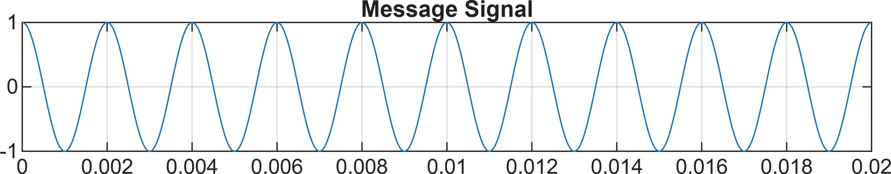

figure; subplot(5,1,2) plot(t,c)
title('Carrier Signal') grid on
subplot(5,1,3) plot(t,am) title('AM Signal') grid on subplot(5,1,4) plot(t,IF)
title('Intermediate Frequency (IF) Signal') grid on
subplot(5,1,5) plot(t,env) title('Recovered Signal') grid on

